Platform Documentation (JSON)

Introduction

Purpose and Scope of this Document
The purpose of this document is to enable system communication between the LILY MOBILE platform and third party clients.
The document provides all required information to allow the third party to conform to the data format the LILY MOBILE platform and enable reception and delivery of messages from and to mobile operators and perform network look-ups on behalf of the third party.
This document cannot be considered a substitute of the Engagement Agreement, thus it does not cover any commercial terms agreed between LILY MOBILE and the third party clients.
The Third party must have already agreed, completed and signed the Engagement Agreement between himself and LILY MOBILE, in order for the connectivity to be active and proceed with the use of it.

Platform Features
Our platform supports the following features:

- HTTP and HTTPS connectivity
- On-Line traffic Reports
- HLR lookup
- Strong security protocols
- High capacity throughput
- Message prioritization
- Subscription management

System Overview

Summary
The messaging API utilizes the JSON interface to allow communication to take place through the HTTP protocol.
The gateway has a transparent functionality as follows:

- Send messages to the third party as received, via the operators, from mobile users.
- Send messages received from the third party to mobile users.
- Send delivery receipts received, via the operators, from mobile users.
- Provide gateway statuses for any errors encountered during message transmission.
- Provide online reports to the third parties.

The Messaging Gateway
The messaging gateway performs all communications through JSON format.
Messages may be sent either as premium rate (PMT) or free to user (F2U), by specifying the billing charge band flag. ‘Premium rate’ or ‘reverse billing’ is considered the charging of a mobile user for messages delivered to their handset.
Messages received via the operators from mobile users, will be forwarded to the third party in the specified JSON format. In this document, this flow of communication will be referred to as TPBound (Third Party Bound).

Platform Connectivity

MT Posting

Description
MT submissions to the platform by the third party shall be made to the Target URL. These URLs will only be available to the third party once an account has been provisioned by LILY MOBILE. The third party’s application shall make all POSTs using the following JSON payloads, for all messages sent to mobile users.

Encoding
During message submissions, the HTTP encoding type is specified within the HTTP header. The gateway has a default encoding type for HTTP POSTs of UTF-8. This allows the gateway to handle characters residing outside the Latin-1 (ISO-8859-1) encoding type range.

Post Details
When POST-ing to the gateway, the third party should hit the SMS send endpoint in the following format:

https://api.lilymobile.gr/sms/{username}/{password}

The table below, illustrates the fields that need to be sent:

Field | Type | Description
Receiver | String | The receiver's MSISDN
Text | String | The SMS body (max 160 characters)
TransactionId | String | The transaction id, by which the SMS will be tracked and receive DLRs (max 50 characters)
ServiceId | Integer | The service which the SMS is sent for
CostId | Integer | The id that corresponds to the SMS short code
NetworkId | Integer | 265 = Cosmote  268 = Vodafone  635 = Wind/NOVA

Valid request:

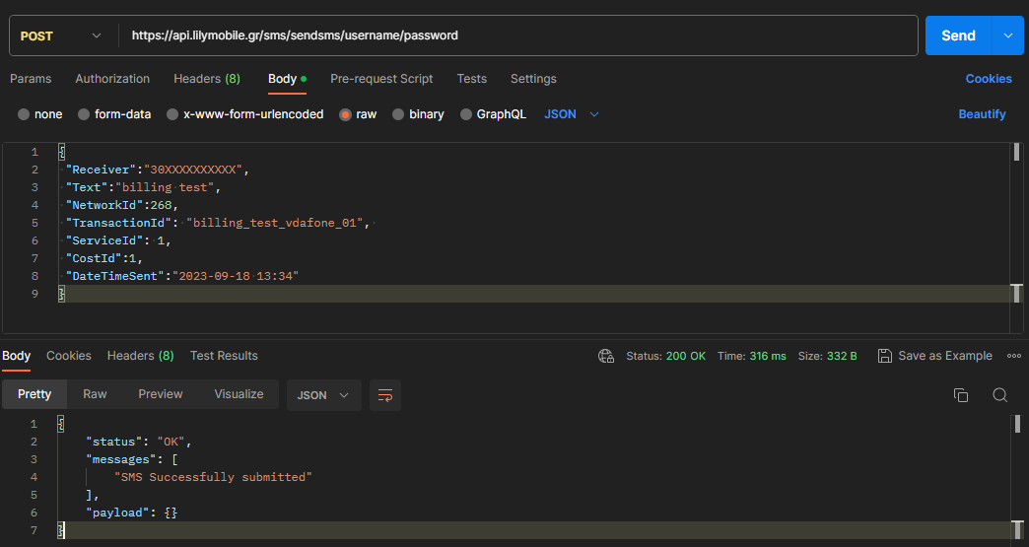

Invalid request:

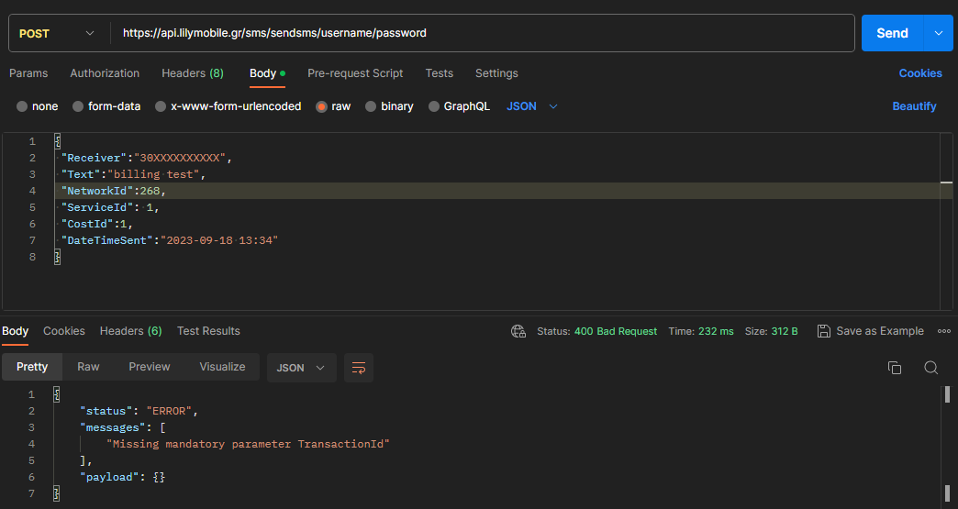

When a HTTP request is made by the third party to the gateway, the login and password that has been agreed must be supplied. The user and password parameters are NOT included within the JSON being sent.
The Content Type in the HTTP header should be set as: Content Type: application/json

Generic Response
Upon submission of a request by the third party, a response will be generated and communicated back to the third party. The provision of such response acknowledges the acceptance of a MT POST request by the messaging gateway. This response does not provide any ongoing message status or substitute a delivery receipt.

MO Posting (TPBound)

Description
The gateway lies as an intermediate between the third party and a mobile user. When a message is received from a mobile user (via the operators), the gateway will forward the message to the third party.
The messages forwarded to the third parties containing the following SMS body:
STOP, STOPALL, STOP ALL, STOP IVR, OK
regardless the short code the SMS was sent to must be processed. If the msisdn is subscribed to any of the third party service must be unsubscribed. If the msisdn is not subscribed it should be ignored.
Encoding
As described in 3.1.2, the default encoding type the gateway is using is UTF-8. All POSTs to the third party will be in this type. The encoding type is specified within the HTTP header.

POST details
The POST request is sent to the third party, containing a JSON payload with the following format:
Field | Type | Description
Sender | String | The sender's MSISDN
Text | String | The SMS body (max 160 characters)
NetworkId | Integer | 265 = Cosmote  268 = Vodafone  635 = Wind/NOVA
Shortcode | String | The short code the SMS was sent to
DateTimeSent | String (yyyy-MM-dd HH:mm:ss:fff) | The date and time the SMS was sent

Generic Response
The third party is required to implement an endpoint to handle all HTTP POSTs sent by our gateway, and provide it with a HTTP Response, confirming that it was received.
Should the gateway not receive a response from the third party, or the third party fails to respond within a 1000ms timeout, the request will enter a retry schedule. Such retries will occur at a 5 minute interval for a total 5 attempts.

Delivery Reports

Description
When our gateway receives a DLR from the operator, a POST request is made to the third party, containing a json payload with the following fields:
Field | Type | Description
TransactionId | String | The transaction id, for which the DLR was received
StatusId | Integer | The delivery status id ( See appendix A )
NetworkId | Integer | 265 = Cosmote  268 = Vodafone  635 = Wind/NOVA
DateTimeDelivered | String (yyyy-MM-dd HH:mm:ss:fff) | The date and time the DLR was received

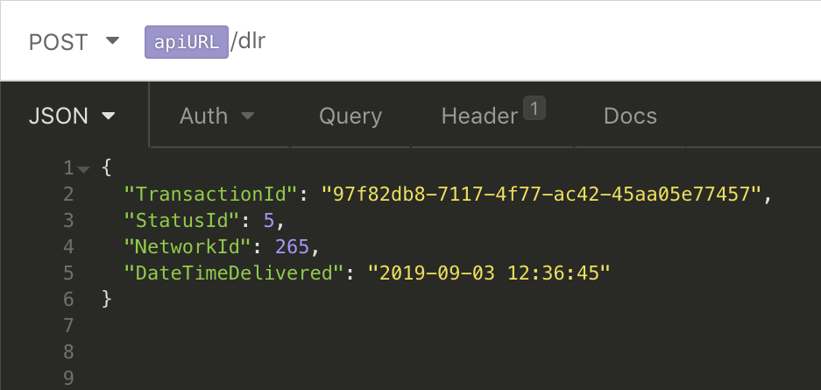

Msisdn Unsubscription

Description
The unsubscription endpoint can be used to notify our LILY MOBILE endpoint about subscription termination.
https://api.lilymobile.gr/sms/unsubscribe/{username}/{password}

Field | Type | Description
MSISDN | String | The MSISDN to be unsusbcribed
Keyword* | String | The KW of the service

method: POST
the payload should be following JSON:
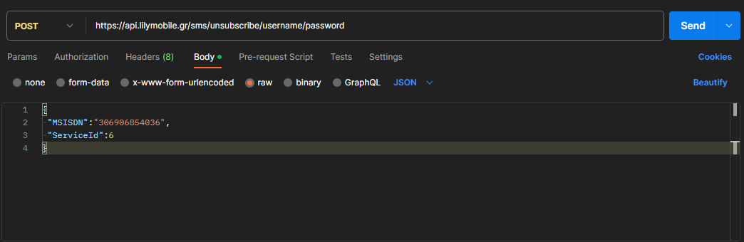
Followed with reply:
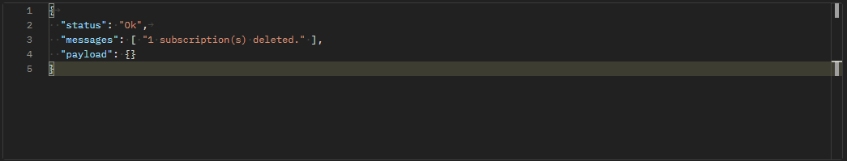
keep in mind that an unsubscription free MT must be send from the third party also if the endpoint is used.

Additional Features

4.1. Home Location Register (HLR) Lookup
The Home Location Register capability enables clients to determine the operator of an MSISDN. Using the HLR Feature is mandatory for the Greek territory since the pre-fix assumption of the operator solution is not valid due to the extensive portability. We are offering the feature at a specific cost which is depicted in the Cooperation Agreement (Appendix D).
Note that upon the non-reception of Network ID in your subscription initiation POST, our platform automatically enables the feature of HLR in order to successfully conclude the subscription process. This automatic enabling results with the aforementioned cost.

4.1.1. Background
Consumers move to a different mobile network regularly. Each user that moves to another network causes lost revenues for the third parties and additional acquisition costs. The gateway also has to handle failed billed messages on our network due to invalid number errors.
A client may build their opt-in list for services by using the MSISDN of the user to communicate with them with offers, subscription content etc. If a user moves network, they will not receive the MT messages anymore, even if the client’s Gateway request asks LILY MOBILE’ platform to route the message. Additionally, mobile networks recycle mobile numbers every 6 months. That means a different user could end up receiving the original owner’s messages. This issue is particularly of concern from a regulatory standpoint.

4.1.2. Benefits
The primary benefit for the third party is information, enabling the continuation of dialogues with consumers by updating opt-in user database entries with the latest Home Network for each person. This reduces the need to re-acquire those customers through expensive marketing.
A further benefit is reduced traffic of attempts to deliver MT messages to invalid consumer mobile phone numbers.
Finally, this Network Query Gateway should reduce the likelihood of support calls from consumers who have received services on a recycled MSISDN.
HLR lookup is performed in order to get the network of a MSISDN.
Please find below details on how to perform a HLR lookup:

4.2 Making HLR requests
When making a HLR request, the third party should hit the HLR endpoint in the following format:

https://api.lilymobile.gr/hlr/v2/{username}/{password}

The table below, illustrates the field that needs to be sent:

Field | Type | Description
MSISDN | String | The receiver's MSISDN

Valid request:
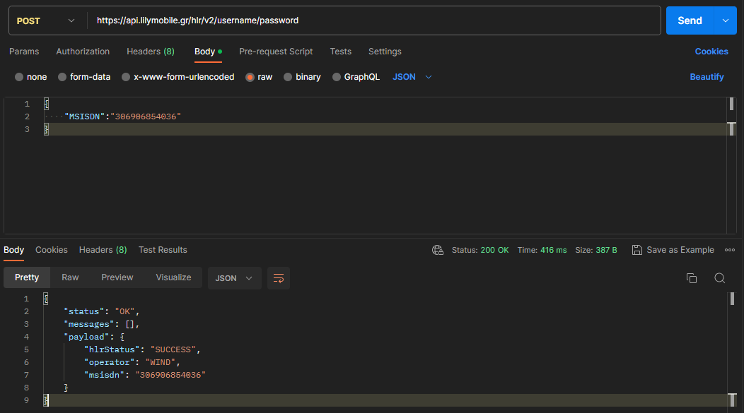
Also the HLR request can be directly used through the SMS subscription endpoint.

SMS subscription process

For the third party to subscribe a MSISDN via SMS, the LILY MOBILE SMS mechanism needs to be implemented.
To initiate the subscription process, a POST request is required, sending the following fields in a JSON payload:
https://api.lilymobile.gr/sms/subsms/{username}/{password}

Field | Type | Description
MSISDN | String | The MSISDN to be subscribed
PINId | Integer | The PIN id for the current service (Given by LILY MOBILE)
NetworkId* | Integer | 265 = Cosmote  268 = Vodafone  635 = Wind/NOVA

*If The NetworkId parameter is not provided the API will perform automatically an HLR request to acquire the network for the specified msisdn.
When the user sends replies with the keyword “OK” to the SMS sent within 5 minutes, the MSISDN will be subscribed to the service.
Valid request:
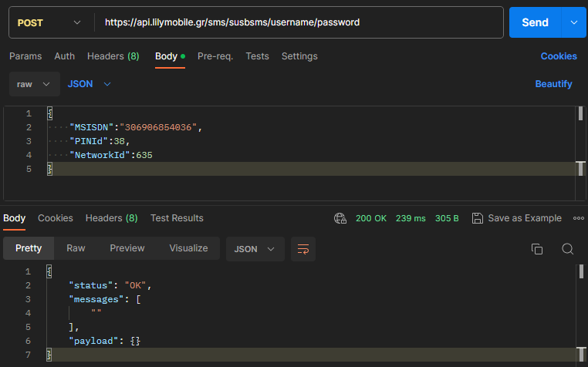

Invalid request:
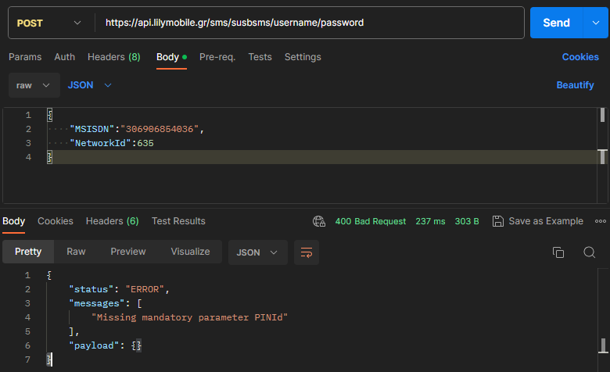

Appendix A

DLR Status codes
Status code | Description
0 | no error
2 | Delivered to operator, when no DLR is requested
3 | Message delivered to operator
5 | Message delivered to handset
6 | Failure at operator
7 | Failed at gateway
10 | Message length invalid
11 | User does not exist in SDP
12 | Originator insufficient credit
13 | User(s) are barred
15 | Invalid source address
16 | Message expired at gateway
17 | Invalid expiry time
19 | Originator insufficient credit
13 | Gateway barred
25 | Generic failure
26 | Expired
27 | Unknown status
208 | Invalid destination address
209 | Invalid type ID
210 | Invalid service ID
211 | Invalid cost ID
213 | Invalid network ID
214 | Invalid priority
217 | Invalid delivery
266 | HLR lookup failed
279 | 20 euro cap
280 | 40 euro cap voda
281 | 20 euro cap will be exceeded

HLR Responses
Response
OK
DATA MISSING
CALL BARRED
ABSENT SUBSCRIBER
UNKNOWN SUBSCRIBER
UNEXPECTED DATA VALUE
FACILITY NOT SUPPORTED
TELESERVICE NOT PROVISIONED
HLR REJECT
HLR ABORTED
HLR LOCAL CANCEL
REQUEST THROTTLED
IMSI LOOKUP BLOCKED
SERVICE FAILURE

LILY MOBILE API responses
All the API calls made to LILY MOBILE, have the same response structure:
status: A string value containing info on whether the request was successful or not
messages: An array with messages that provide info regarding the request
payload: A JSON payload, which contains the API response, where applicable.

